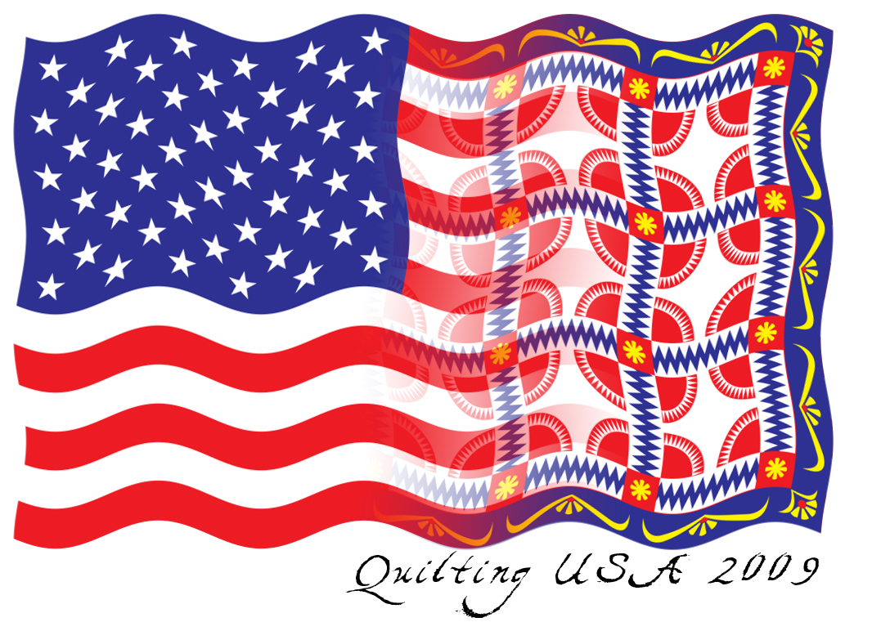
Friendship Star Quilters Present
“Quilting USA”
Quilt Show 2009

Bigger than ever, this year FSQ brings more quilts, more vendors, and an exhibit of quilts made for our service projects, to the 2009 quilt show, April 24-26 at the Montgomery County Fairgrounds in Gaithersburg, Maryland.

Placing an advertisement in the FSQ Show Catalogue ensures that your information will be seen by more than 1,000 quilters and their families and friends. Every one attending will receive a complimentary catalogue. Advertising in the show catalogue is an excellent opportunity to highlight your business and reach your target audience.

To order an ad, send a hard copy of your camera ready art. (Digital copy may be sent to Linda August at
augielg@comcast.net.) Complete this form, indicate the size you desire (please respect the size requirements below), sign, date, enclose your payment, and send to the address below. Our show catalogue is in black and white. Questions, call Laurie Bay at 301-916-5160.

ADVERTISING DEADLINE
MARCH 13, 2009

Signature____________________________________________Date___________________________

Print Name__________________________________________Phone__________________________

Business Name______________________________________________________________________

Address____________________________________________________________________________

_____________________________________________________________________________

❑ FULL PAGE-------------$ 110.00
Actual size 7 7/8" x 10 1/8"

❑ HALF PAGE-------------$ 70.00
Actual size 7 7/8" x 5" (horizontal)

❑ QUARTER PAGE------$ 40.00
Actual size 3 7/8" x 5"

❑ BACK COVER---------$ 150.00

❑ INSIDE COVER--------$ 135.00

At this time we can only accept payment by check.
Thank you for understanding.

www.friendshipstar.org

❑ EIGHTH PAGE----------$ 25.00
Actual size 3 7/8" x 2 1/4" (horizontal)

PERFECT FOR
A BUSINESS CARD

Make all payments payable to
FSQ,
and mail to:

Laurie Bay
20300 Mallet Hill Court
Germantown, Maryland 20876

